**Name: Nafinur Leo**

**Id: 20-42195-1**

**Course Name: Data Communication**

**Section: D**

**Lab Report Number: 05**

**Semester: 2021-2022 Fall**

**Submission Date: 08-11-2021**

**Lab Performance Task**

ID = AB-CDEFG-H

Here, my id is: 20-42195-1

A = 2, B = 0, C = 4, D = 2, E = 1, F = 9, G = 5, H = 1

8 Bit ASCII characters:

E = 1 = 00110001

F = 9 = 00111001

G = 5 = 00110101

Bit stream (24 Bits):

001100010011100100110101

r = 3

L = 8

1. 8-ASK (Amplitude Shift Key):

Code:

clear all

close all

clc

x = [0 0 1 1 0 0 0 1 0 0 1 1 1 0 0 1 0 0 1 1 0 1 0 1];

nx = length(x);

m1 = 1;

m2 = 1.5;

m3 = 2;

m4 = 2.5;

m5 = 3;

m6 = 3.5;

m7 = 4;

m8 = 4.5;

f1 = 1;

p1 = 0;

pd = 2;

i = 1;

fs = 50000;

while i<nx+1

t = (i-1)/3*pd:1/fs:(i+2)/3*pd;

if x(i)==0 && x(i+1)==0 && x(i+2)==0

ask = m1*sin(2*pi*f1*t);

elseif x(i)==0 && x(i+1)==0 && x(i+2)==1

ask = m2*sin(2*pi*f1*t);

elseif x(i)==0 && x(i+1)==1 && x(i+2)==0

ask = m3*sin(2*pi*f1*t);

elseif x(i)==0 && x(i+1)==1 && x(i+2)==1

ask = m4*sin(2*pi*f1*t);

elseif x(i)==1 && x(i+1)==0 && x(i+2)==0

ask = m5*sin(2*pi*f1*t);

elseif x(i)==1 && x(i+1)==0 && x(i+2)==1

ask = m6*sin(2*pi*f1*t);

elseif x(i)==1 && x(i+1)==1 && x(i+2)==0

ask = m7*sin(2*pi*f1*t);

else

ask = m8*sin(2*pi*f1*t);

end

i = i+3;

plot(t,ask)

hold on

xlabel('time');

ylabel('amplitude');

title('Amplitude Shift Key');

end

hold off

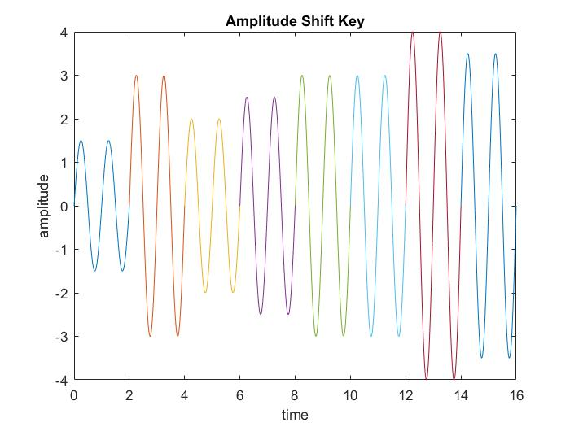

2. 8-FSK (Frequency Shift Key):

Code:

clear all

close all

clc

x = [0 0 1 1 0 0 0 1 0 0 1 1 1 0 0 1 0 0 1 1 0 1 0 1];

nx = length(x);

m1 = 1;

f1 = 1;

f2 = 1.5;

f3 = 2;

f4 = 2.5;

f5 = 3;

f6 = 3.5;

f7 = 4;

f8 = 4.5;

p1 = 0;

pd = 2;

i = 1;

fs = 50000;

while i<nx+1

t = (i-1)/3*pd:1/fs:(i+2)/3*pd;

if x(i)==0 && x(i+1)==0 && x(i+2)==0

fsk = m1*sin(2*pi*f1*t);

elseif x(i)==0 && x(i+1)==0 && x(i+2)==1

fsk = m1*sin(2*pi*f2*t);

elseif x(i)==0 && x(i+1)==1 && x(i+2)==0

fsk = m1*sin(2*pi*f3*t);

elseif x(i)==0 && x(i+1)==1 && x(i+2)==1

fsk = m1*sin(2*pi*f4*t);

elseif x(i)==1 && x(i+1)==0 && x(i+2)==0

fsk = m1*sin(2*pi*f5*t);

elseif x(i)==1 && x(i+1)==0 && x(i+2)==1

fsk = m1*sin(2*pi*f6*t);

elseif x(i)==1 && x(i+1)==1 && x(i+2)==0

fsk = m1*sin(2*pi*f7*t);

else

fsk = m1*sin(2*pi*f8*t);

end

i = i+3;

plot(t,fsk)

hold on

xlabel('time')

ylabel('amplitude')

title('Frequency Shift Key')

end

hold off

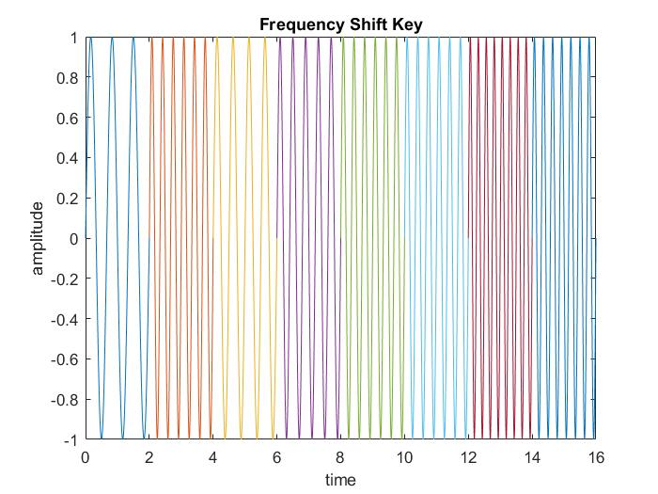

3. 8-PSK (Phase Shift Key):

Code:

clear all

close all

clc

x = [0 0 1 1 0 0 0 1 0 0 1 1 1 0 0 1 0 0 1 1 0 1 0 1];

nx = length(x);

m1 = 1;

f1 = 1;

p1 = 0;

p2 = 45;

p3 = 90;

p4 = 135;

p5 = 180;

p6 = 225;

p7 = 270;

p8 = 315;

pd = 2;

i = 1;

fs = 50000;

while i<nx+1

t = (i-1)/3*pd:1/fs:(i+2)/3*pd;

if x(i)==0 && x(i+1)==0 && x(i+2)==0

psk = m1*sin(2*pi*f1*t + p1);

elseif x(i)==0 && x(i+1)==0 && x(i+2)==1

psk = m1*sin(2*pi*f1*t + p2);

elseif x(i)==0 && x(i+1)==1 && x(i+2)==0

psk = m1*sin(2*pi*f1*t + p3);

elseif x(i)==0 && x(i+1)==1 && x(i+2)==1

psk = m1*sin(2*pi*f1*t + p4);

elseif x(i)==1 && x(i+1)==0 && x(i+2)==0

psk = m1*sin(2*pi*f1*t + p5);

elseif x(i)==1 && x(i+1)==0 && x(i+2)==1

psk = m1*sin(2*pi*f1*t + p6);

elseif x(i)==1 && x(i+1)==1 && x(i+2)==0

psk = m1*sin(2*pi*f1*t + p7);

else

psk = m1*sin(2*pi*f1*t + p8);

end

i = i+3;

plot(t,psk)

hold on

xlabel('time')

ylabel('amplitude')

title('Phase Shift Key')

end

hold off

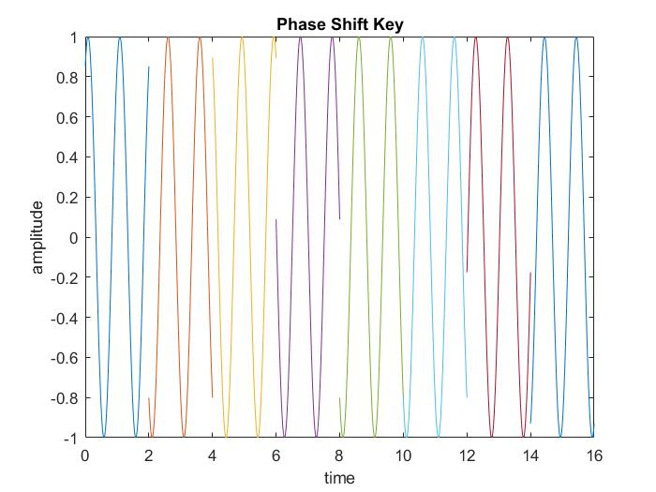

**Discussion:**

There is some of the bugs concluded with the definite organizational complementation with the functions of the MATLAB. The regression of the functions originated from the libraries inclines the comprehensive objective of this complementation. I face some problems while creating the plot and also face problems while calculation using my student id number. MATLAB takes some time while I try to run because my laptop configuration is low.